Betting Game

Software Requirements Specification

For Android Application

Version 1.2

Revision History

|  |  |  |  |
| --- | --- | --- | --- |
| **Date** | **Version** | **Description** | **Author** |
| 22/10/15 | 1.0 | Putting in information | André Helbig |
| 23/10/15 | 1.1 | Editing UCD | Felix Morsbach |
| 01/11/15 | 1.2 | Replacing Function-Description with Links | Felix Morsbach |
|  |  |  |  |

Table of Contents

1. Introduction 5

1.1 Purpose 5

1.2 Scope 5

1.3 Definitions, Acronyms, and Abbreviations 5

1.4 References 5

1.5 Overview 5

2. Overall Description 6

3. Specific Requirements 7

3.1 Functionality 7

3.1.1 Login 7

3.1.2 Register 7

3.1.3 Edit personal User Data 7

3.1.4 Manage User Data 7

3.1.5 Give Feedback 7

3.1.6 Give Support 7

3.1.7 Check Leaderboard 7

3.1.8 Instant messaging 7

3.1.9 Bet on win 7

3.1.10 Wager bets 7

3.1.11 Rewards 7

3.1.12 Results 7

3.1.13 Leaderboard 7

3.1.14 Notifications 7

3.1.15 Live ticker 7

3.1.16 Timing and synchronization 8

3.2 Usability 8

3.2.1 Availability 8

3.2.2 Audit and control 8

3.2.3 Accessibility 8

3.2.4 Backup 8

3.2.5 Capacity 8

3.2.6 Certification 8

3.2.7 Compliance 8

3.2.8 Configuration management 8

3.2.9 Dependency on other parties 8

3.2.10 Deployment 8

3.3 Reliability 8

3.4 Performance 8

3.5 Supportability 8

3.6 Design Constraints 8

3.7 On-line User Documentation and Help System Requirements 8

3.8 Purchased Components 8

3.9 Interfaces 9

3.9.1 Software Interfaces 9

3.10 Licensing Requirements 9

3.11 Legal, Copyright, and Other Notices 9

3.12 Applicable Standards 9

4. Supporting Information 9

Software Requirements Specification

# Introduction

## Purpose

[www.blogsiteloremipsum.de/?p=8](http://www.blogsiteloremipsum.de/?p=8)

## Scope

This document is only meant for internal use in the project.

## Definitions, Acronyms, and Abbreviations

n/a = not applicable

## References

Blog [www.blogsiteloremipsum.de](http://www.blogsiteloremipsum.de)

GitHub <https://github.com/GamingBets>

## Overview

The following document is an overview of the Use Cases, their description and other functionalities of our application.

# Overall Description

# 

# Specific Requirements

## Functionality

### Login

<https://github.com/GamingBets/documents/blob/master/Use%20Case/Login/UCSLogin.docx>

### Register

<https://github.com/GamingBets/documents/blob/master/Use%20Case/Register/UCSRegister.docx>

### Edit personal User Data

<https://github.com/GamingBets/documents/blob/master/Use%20Case/Edit%20User%20Data/UCSEditData.docx>

### Manage User Data

<https://github.com/GamingBets/documents/tree/master/Use%20Case/Manage%20User%20Data>

### Give Feedback

<https://github.com/GamingBets/documents/blob/master/Use%20Case/Give%20Feedback/UCSFeedback.docx>

### Give Support

<https://github.com/GamingBets/documents/blob/master/Use%20Case/Give%20Support/UCSSupport.docx>

### Check Leaderboard

<https://github.com/GamingBets/documents/blob/master/Use%20Case/Check%20Leaderboard/UCSLeaderboard.docx>

### Instant messaging

Logged in users will be able to chat with each other using instant messaging client.

### Bet on win

<https://github.com/GamingBets/documents/blob/master/Use%20Case/Bet%20on%20Win/UCBetOnWin.docx>

### Wager bets

<https://github.com/GamingBets/documents/blob/master/Use%20Case/Wager%20Bet/UCWagerBet.docx>

### Rewards

<https://github.com/GamingBets/documents/blob/master/Use%20Case/Buy%20rewards/Buy%26Get%20rewards.docx>

### Results

<https://github.com/GamingBets/documents/blob/master/Use%20Case/Check%20Game%20Results/UCCheckGameResults.docx>

### Leaderboard

In our leaderboard the best players will be awarded with special prizes and fame.

### Notifications

The user will be notified via email or push notification about the results of his bets.

### Live ticker

The user can check current match status.

### Timing and synchronization

The synchronization does not have to be that precise as long as the match data is ready after the match is finished (for the betting)

## Usability

### Availability

The app is available 24/7 as long as you have an internet connection.

### Audit and control

n/a

### Accessibility

n/a

### Backup

All relevant data will be saved on a database and code will be backed up in github.

### Capacity

to be determined

### Certification

n/a

### Compliance

n/a

### Configuration management

n/a

### Dependency on other parties

We use API from other parties to get the game data for our bets.

### Deployment

Google Play store

## Reliability

The application should run stable at all times.

## Performance

The loading times should be less than a couple of seconds at all times.

## Supportability

### Technologies

Die APP soll auf allen mobilen Geräten lauffähig sein welche mindestens die Android Version 4.1 besitzenDesign Constraints

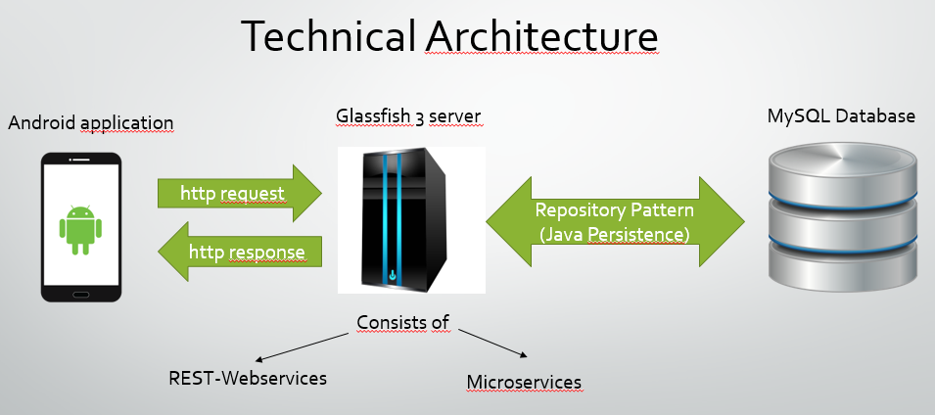

* GitHub for code and documentation
* Glassfish 3 Server
* MySQL Database
* Android Studio as DIE
* JIRA
* Gherkin
* JUNIT

## On-line User Documentation and Help System Requirements

n/a

## Purchased Components

n/a

## Interfaces

### Software Interfaces

Connection to a database for game data with different API’s if possible.

## Licensing Requirements

to be determined

## Legal, Copyright, and Other Notices

to be determined

## Applicable Standards

to be determined

# Supporting Information

to be determined